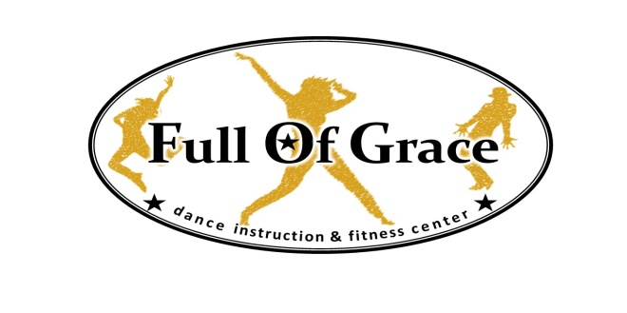

FOG SEPTEMBER NEWSLETTER
Welcome to Full of Grace's 12th Year of Dance!!! We are so excited to have all of you with us this year. Let's make this year the best YET!
Registration Forms:
If you have not yet returned your registration forms and medical release sheet to Velvet in the office please do so this week.
Monthly Fees:
Monthly fees are due on the first class of each month. If you need to discuss payments please speak to Velvet directly. If she doesn't hear from you she will ask you during the second week to come talk to her at the office. If payment or arrangements are not made by the second week a $50 late fee will be assessed. Please note a new payment policy will be sent out to each of you in the coming days.
Office Hours:
Monday and Wednesday - 3:00-7:30 and Tuesday 2:45-7:00 - Please bring payments to the office or drop in the box. Velvet can also be reached via email at fogvelvet@gmail.com
Bring a Friend Week:
September 29-October 3rd will be Bring A Friend to Dance Week. A flier is attached and was handed out at the studio or you can pick up another one.
This gives the opportunity for the kids to show their friends why they like dance and to give their friends a chance to try it out to see if they would like to join!! Help spread the word about this opportunity to all your family and friends.

Fundraisers for Costumes:
Pampered Chef Fundraiser will run Sept 8 - Sept 29. This fundraiser is available at the office for pickup. You can earn 25% off the products you sell toward your costume fees. Pick one up at the office today.
Poinsettia Fundraiser will starts October 3rd - October 23rd (when the office closes).
Costume Fees Due:
Costume fees will be due the first week of November. Totals will be provided to you in October.
Competition Team Information:
Many of the kids come directly from school on Monday and Wednesdays. Please send snacks and or dinner with them. We have a refrigerator where they can but drinks and food.
Mandatory Staff Conference:
Saturday, September 27th @ 9am - All Teachers, Teachers in Training, Assistant Teachers, Karate Teachers and Office and Grounds Staff
Studio Closures and Events:
October 31 - Closed for Halloween
November 24th - Competition Team Secret Santa Names Drawn
November 26-30 - Closed for Thanksgiving
December 7th - Holiday Show at the NV High School with Dessert Auction
December 16th and 17th - Class Christmas Party
December 17th - Competition Team Christmas Party and Secret Santa
December 20-Jan 4th - Studio Closed for Christmas

Competition and Performance Team Information:
Competitions:
Non-Mandatory Workshop to Attend - Sophisticated Production Workshop November 14&15th - Place and Prices TBD
We will be participating in possibly three mandatory competitions this year.
Possibly: Sophisticated Productions Competition - February 27-March 1, 2015 - Syracuse NY
Location TBD
Access Broadway - Lake George April 10-12,2015
The Sagamore Resort $124/night 866-385-6221 Please make your reservations.
Legacy Dance Competition - April 17-19, 2015 Utica NY @ Stanley Center for the Arts
Hotels Nearby:
Hotel Utica
102 Lafayette Street
Utica, NY 13502
1.877.906.1912
Rosemont Inn
423 Genesee Street
Utica, NY 13501
866.353.4907

The Radisson Hotel
200 Genesee Street
Utica, NY 13502
315.797.8010
Access Broadway Nationals (Not Mandatory) - July 6-11, 2015 Hershey Lodge
Many people stay at the affordable:

Elizabethtown / Hershey KOA
1980 Turnpike Road
Elizabethtown, PA 17022
Reserve: 800-562-4774
Info: 717-367-7718
Reservations for 2015 Begin the second week of January.
FUNDRAISERS FOR PERFORMANCE AND COMPETITION TEAMS:
Feet on The Street Dance Marathon and Workshop - @ Studio Friday, October 17th From 8pm-8am (Lock In) For Ages 10 and Up
Fee is $50.00 - Each contestant can raise money by getting donations to enter the Dance Workshop/Marathon any money raised in excess of the $50 will go to the Josyln Juvenile Diabetes Foundation
Contestants Receive:
1. Opportunity to Win Grand Prize
2. Feet on The Street Dance Marathon/Workshop T-Shirt
3. Food and Beverages throughout the event
4. Portion of the Entry Fee is Donated to the Juvenile Diabetes Foundation

Will we need parents to volunteer to work this event. Please let Velvet know if you are willing to help. Any remaining proceeds will go toward the FOG Performance Team.

Performance Team
First performance at the Oakdale Mall October 25th. Time will be given as soon as possible.
NV Craft Show - Performance Team will do face painting and a chocolate candy sale. We cannot do a normal bake sale because the Auxiliary is doing one. NV Fire station Saturday, November 1st 9am-3pm
Competition Team
Halloween Monster Bash - NV Fire Station - Saturday, October 18th
Performance Team will be doing a Performance times TBD

Paddle Party - Sunday, November 16th @ NV Fire Station - the Competition Team will be performing at various times during the day. We will have a Bake Sale so please provide one or more baked items for sale. This fundraiser will benefit the Competition Team. If anyone else in the studio would like to come support the team and/or bring bake sale items it would be greatly appreciated. Please spread the word about this great event.
Christmas Show - Sunday, December 7th @ NV High School - All Classes will dance. We will have our Annual Dessert Auction - Donations are Welcome.

